EXPERIMENT 5

DDL COMMANDS (COLLEGE SCHEMA)

Aim:

* Create a schema called College.
* Create tables for students (attributes: student id, name, gender, subject, marks and grade), faculty (attributes: faculty id, name, course and pass percentage), department (attributes: department id, name, section, strength and pass percentage) and activity (attributes: activity id, name, strength and category)
* Add and modify:
  + Address in students table, change datatype size of student name and make student id primary key
  + Add faculty total mentor details, make faculty id as primary key
  + Add number of students in wise in department table and make department id as primary key
  + Add faculty name to activity table, change the datatype size of activity name and make activity id as primary key
* Create a schema called College.

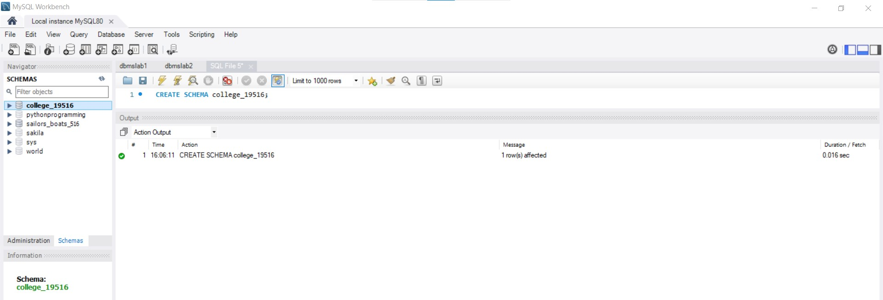

* Create tables for students (attributes: student id, name, gender, subject, marks and grade), faculty (attributes: faculty id, name, course and pass percentage), department (attributes: department id, name, section, strength and pass percentage) and activity (attributes: activity id, name, strength and category)

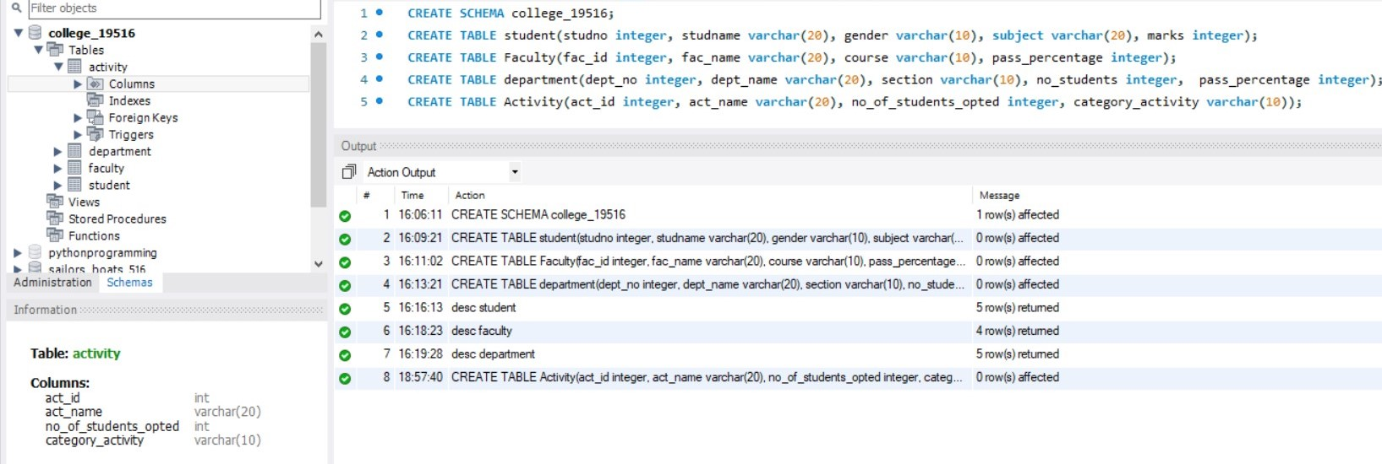

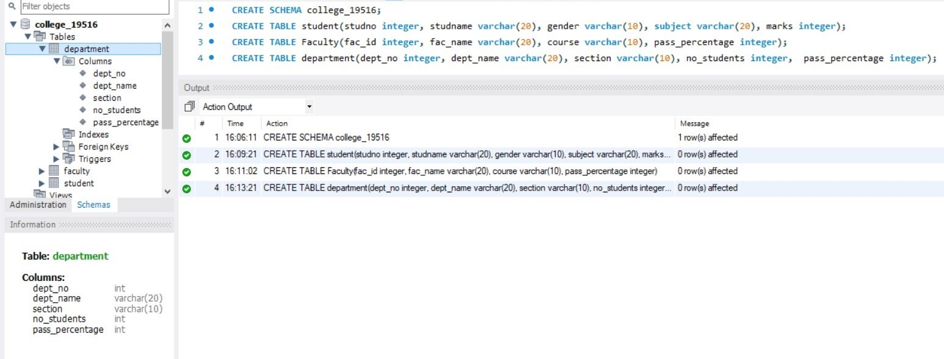



* Add and modify:
  + Address in students table, change datatype size of student name and make student id primary key
  + Add faculty total mentor details, make faculty id as primary key
  + Add number of students in wise in department table and make department id as primary key
  + Add faculty name to activity table, change the datatype size of activity name and make activity id as primary key

